
Essentials Mathematics Test #8

60
Topics – Statistics & Data

Name | Solution

- Attempt all questions
- Show all working and calculations where possible
- Calculators are allowed
- One A4 page of notes is allowed

You must include all working out to receive full marks

Question 1 (10 marks)
From the list of data displays below, choose the most appropriate way to display the data described in each part below and explain the reasons for you choice.
- Column graph
- Dot frequency diagram
- Back to back stem and leaf diagram
- Histogram

- The heights (measured in cm) of 20 boys and 20 girls to compare them.
Back to Back Stem & Leaf Plot

- The eye colour of all Year 11 students.
Dot Frequency

- The foot length, measured in cm, of the members of your class. Histogram

- The percentage of students in each year at our school.
Column Graph

- The heights, measured in cm, of all Essentials students.
Histogram

Question 2 (5 marks)
This dot plot shows the foot length of a group of students.
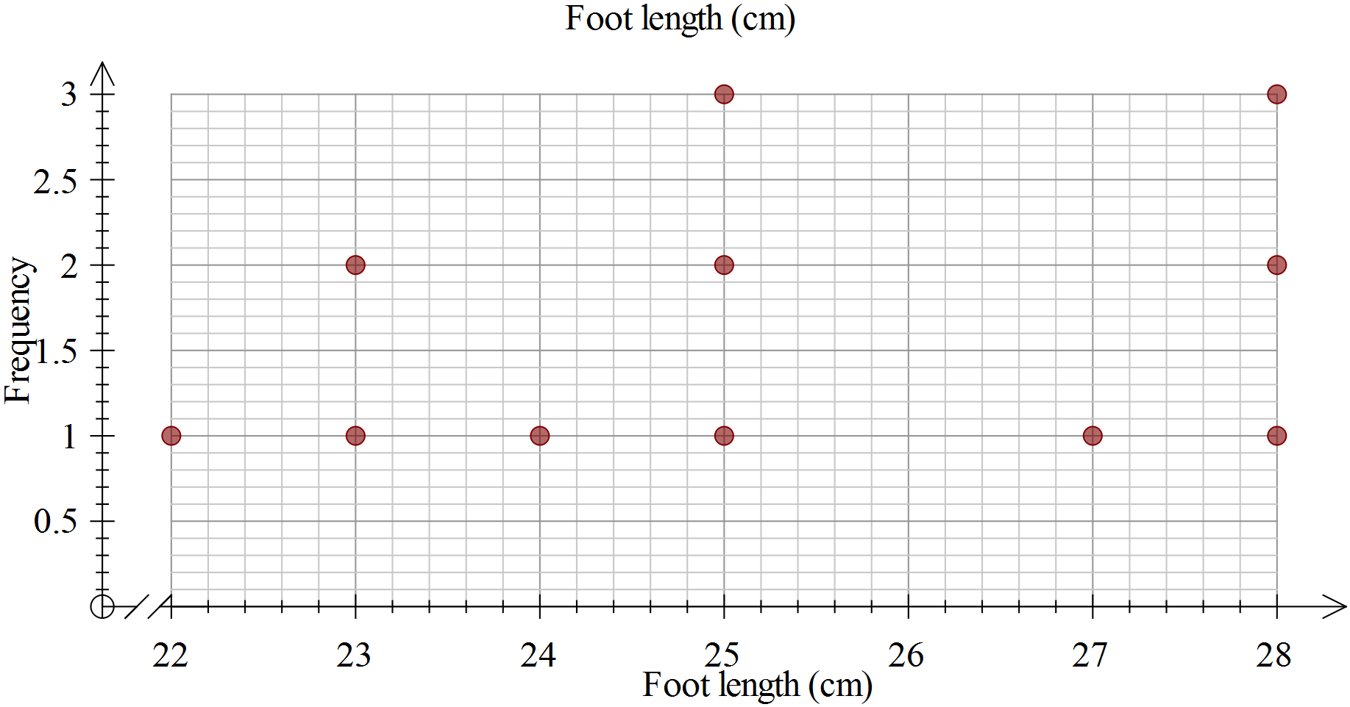
- Calculate the range of the scores, showing your working.
Range = max-min = 28-22=6
- Determine the mode.
Bimodal = 25, 28
- Determine the median.
25
- Calculate the mean, showing your working.
278/11 25.3
- Complete this sentence: For a student in this group, you would expect them to

have a foot length of about __25____cm.

Question 3 (3 marks)
Two classes are marked on the same tests.
Class P has a mean of 65% and standard deviation of 5.
Class Q has a mean of 50% and standard deviation of 15.
- Write a statement comparing the scores of the two classes, that is who had the better scores?
P- higher average scores
Q –lower average score

- Write a statement comparing the spread of the scores for the two classes.
P- most scores are close to the mean/tightly packed
Q- very spread out from the mean/spread out

- Which class would you expect to have the highest score? Explain.
Q-50 + 3 x 15 > 65 + 3 x 5

Question 4 (20 marks – 2, 8, 6, 4)
Height (cm)
Year 7 students
Female | Male
106 | 141
142 | 142
143 | 148
144 | 148
147 | 149
147 | 149
152 | 150
152 | 150
153 | 154
153 | 154
155 | 156
155 | 156
157 | 157
160 | 158
162 | 159
164 | 164
165 | 165
170 | 169
172 | 170
176 | 170
Consider the data to the right, showing the heights of 20 male and 20 female Year 7 students, taken from CensusAtSchool.
- Circle or highlight any outliers in the data.
For any you find, explain why you consider it an outlier.

106 too small to be the height

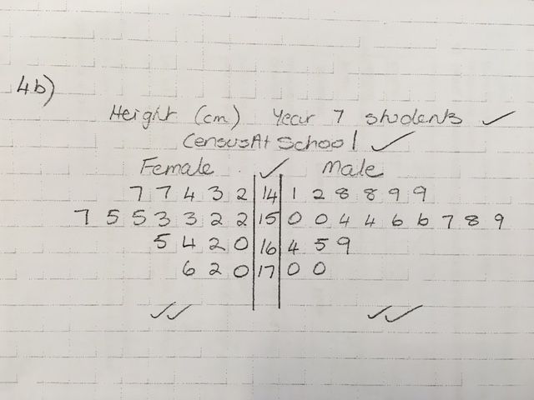
- Use the grid paper provided to make a back-to-back stem and leaf diagram to display this data.

- Complete the table below, showing your working, to summarize the statistics for this data.
Statistic | Female | Male
Mode | No Mode | No Mode
Median | 155 | 155
Range | 176-142 = 34 | 170 – 141 = 29

- Using your stem and leaf plot and/or the table in c), compare the data for males and females.
In what ways are the two groups similar?
Median same
Symmetrical stem and leaf
In what ways are the two groups different?
Male lower range
Female highest value
Question 5 (22 marks-2, 10 ,4 , 6)
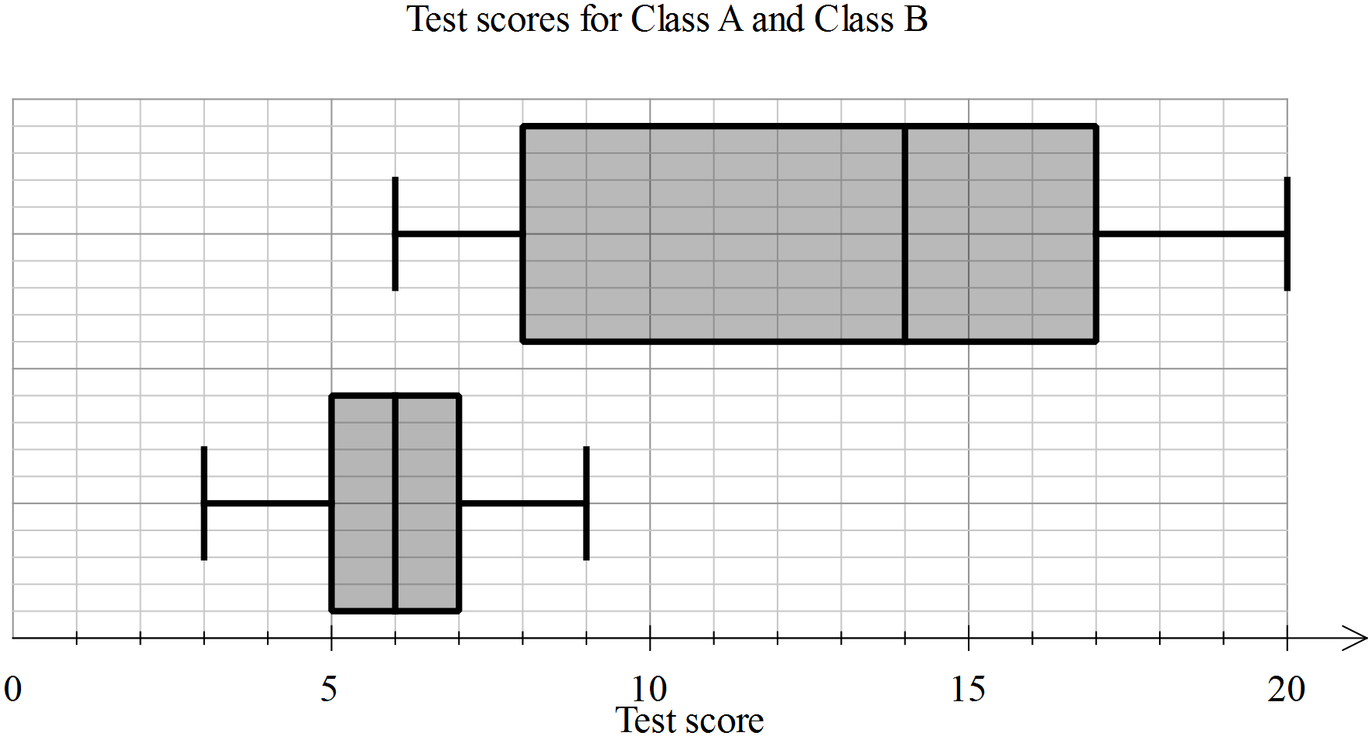

A
B
- Eric is in Class A, he scored 5 on the test. Label the two box plots with their class names.
- Use the table below to enter the appropriate values for each of the plots.
Statistic | Class A | Class B
Minimum | 3 | 6
First quartile | 5 | 8
Median | 6 | 14
Third quartile | 7 | 17
Maximum | 9 | 20

Calculate the range and interquartile range for each class, showing the working, in the table below.

Statistic | Class A | Class B
Range | Max-min 9-3=6 | Max-min 20-6=14
Interquartile range | 3rd – 1st = 7-5 = 2 | 3rd – 1st = 17-8 = 9

- In each of the statements below, write A and B as appropriate to make the statement true.
- Class _B__ has a much greater range than Class _A__
- The minimum for Class _B__ is the same as the median for Class __A_
- For Class _B__, the second and third quartiles are the same width, whereas for Class __A_, the second quartile is much greater than the third quartile.

END OF TEST

